SET-5

1. Create 2 matrixes X and Y with dimensions 3x3
(i) Perform the operation 7X+ Y 3
(ii) Perform the matrix multiplication of x and Y
(iii) Display the diagonal elements and rank of the matrix

2. Program to find the reverse of given number

1)PROGRAM
import numpy as np
x = np.random.randint(20, size=(3, 3))
print("Matrix x:")
print(x)
y = np.random.randint(20, size=(3, 3))
print("Matrix y:")
print(y)

#i)Perform the operation 7x+y^3
print("Perform the operation 7x+y^3: \n",np.add((np.multiply(x,7)),(np.power(y,3))))

#ii)Perform the matrix multiplication of x and y
print("Matrix multiplication of x and y:")
m = np.dot(x,y)
print(m)

#iii)Display the diagonal elements and rank of the matrix
d=np.diag(m)
print("Diagonal elements")
print(d)
rank = np.linalg.matrix_rank(m)
print("Rank of the Matrix")
print(rank)

OUTPUT
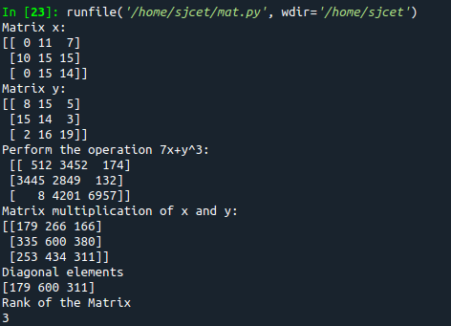

2)PROGRAM
num = int(input("Enter any number: "))
rnum = 0
while num != 0:
digit = num % 10
rnum = rnum * 10 + digit
num //= 10
print("Reversed Number: " + str(rnum))
OUTPUT
